## Photoresistor module

#### Overview：

This class will use photoresistor to print out the values on the serial port.

#### **Materials：**

Arduino Uno x 1

Photoresistance x1

DuPont wires x 3

#### **Product description :**

A photo resistor is a kind of resistor using a photoelectric effect of a semiconductor, which changes the resistance depending upon the intensity of incident light. The higher the incident light, the higher the resistance.

Photo resistors are generally used for light measurement and light control.

#### **Technical Parameters ：**

Maximum voltage (V-dc): 150

Maximum power consumption (mW): 100

Ambient temperature (° C): - 30 --- +70

Spectral peak (nm): 540

Bright resistance (10Lux) (KΩ): 10-20

Dark resistance (MΩ): 1100λ10: 0.6

Response time (ms): up: 20

#### **Wiring diagram:**

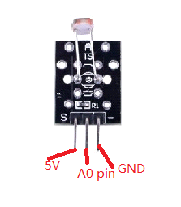

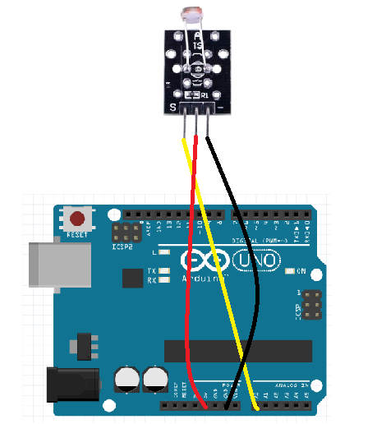

**Example code:**

|  |
| --- |
| **int sensorPin = A0;**  **int value = 0;**  **void setup() {**  **pinMode(sensorPin, INPUT);**  **Serial.begin(9600);**  **}**  **void loop() {**  **value = analogRead(sensorPin);**  **Serial.println(value);**  **delay(200);**  **}** |

**Experimental phenomena：**

Print analog values in the serial port.

